Game Jam is a festival for game developers, where previously unmet designers, programmers, artist, musician meet in the same place to create a game in 48 hours. Games are created around a theme only known to the administrator beforehand. This year’s theme is “transmission”.

My team decided to go with sub theme “transmission of ideas”, trying to make our game a tool to help improve player to player interaction. Our game is a 2d platformer puzzle solver that requires two players to begin with. Every one of the puzzle, even the dialogue, requires information that can only be gathered from each of the player to be combined into one. Individual information players gathered will not make sense until they see the other half of the information, forcing players to exchange ideas outside of the game verbally to beat the level and increasing the human-human interaction along the way.

Games are social in its essence. Upon creation, games are played by multiple people. Even single player games lose their excitement without comparison to the friends. But we currently live in a world so fast paced that players have no time for humanly interaction whatsoever. In addition, the high-end graphics enables game developer to create games with better and better immersion effect, encouraging players to immerse in their own world.

But SYNC encourages players to do otherwise. The more actively and fluently players can communicate, the better chance they get to defeat the game. A lot of players on the show-day cannot get hold of the idea, showing inefficiency communicating with the player next to him/her and thus failing horribly, probably because game as a medium already loses its effect of being a facilitator between human interactions. I hope our game can once again activate the interactions between players and help them socialize.

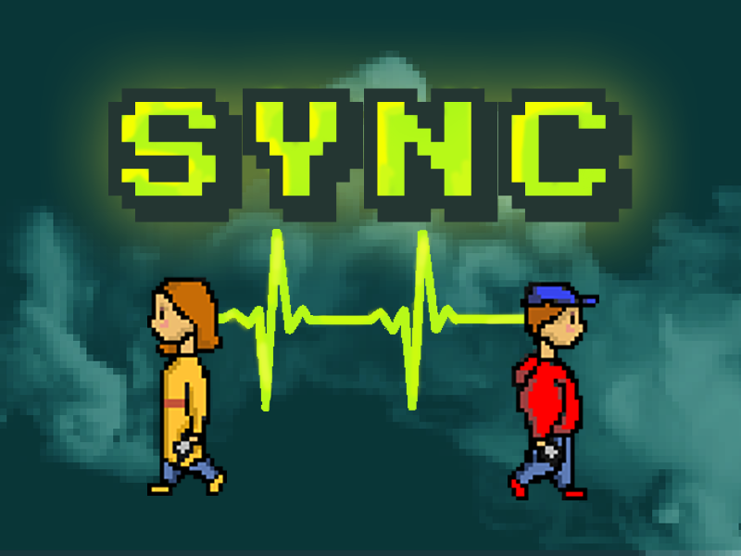

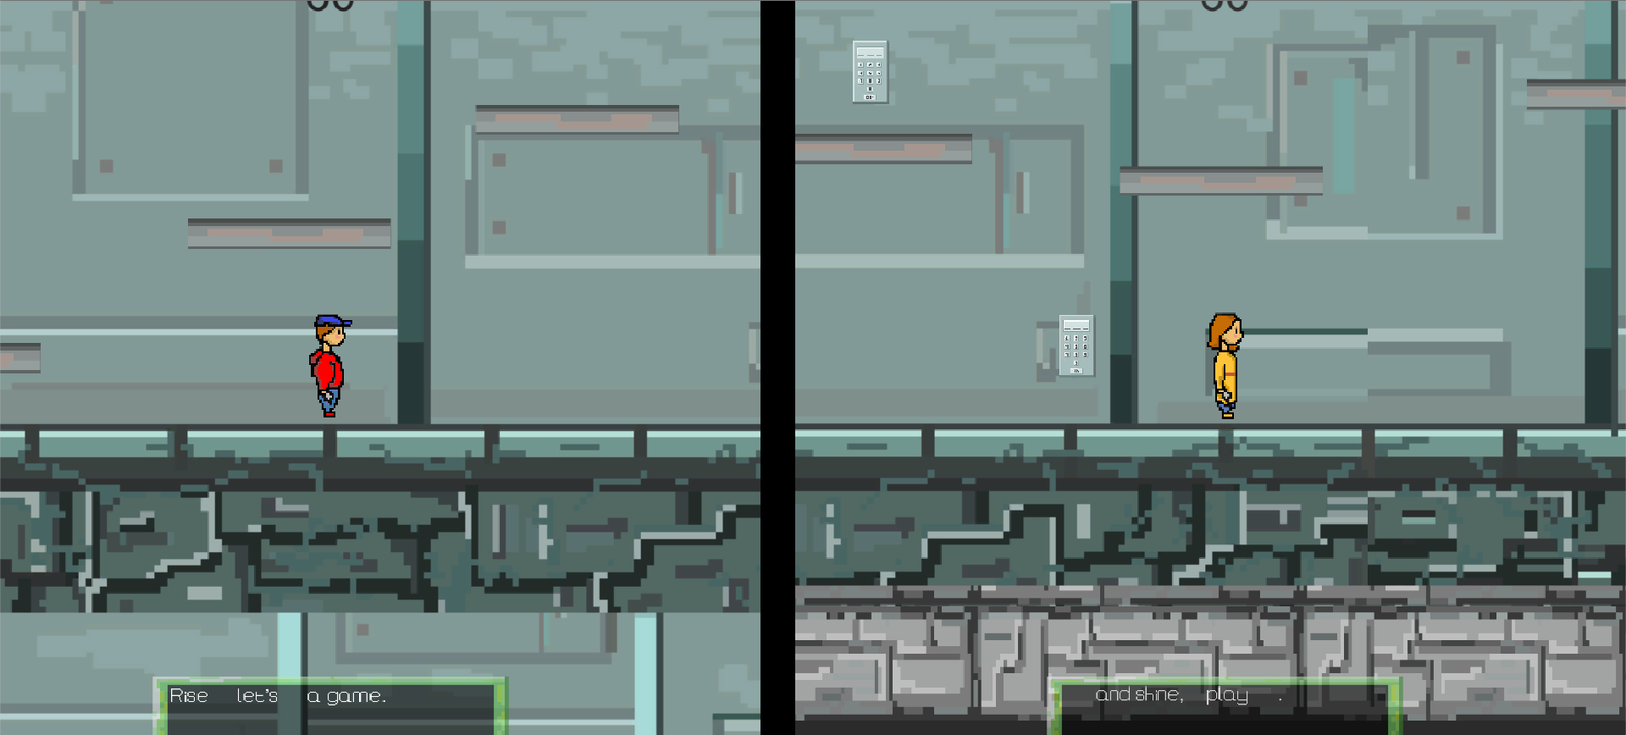

Image-1: Intro dialogue is cut in half and assigned to each player, need to combine them into one sentence

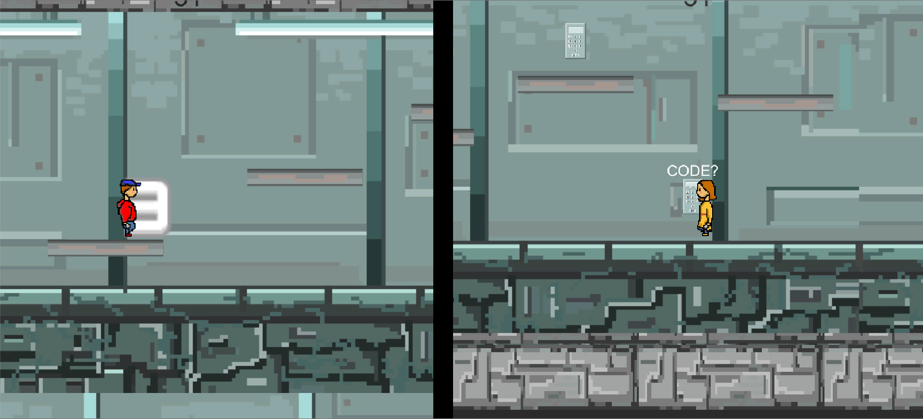

Image-2: An example in which one player is asked to input code while the second player actually finds out about them. Without player on right, left player’s number does not make any sense and vice versa.